UNIT –1- INTRODUCTION

Networks Basics, Network Topologies, WAN, LAN, MAN, Examples of Networks: Novell Networks, Arpanet, Internet, OSI, TCP/IP and other networks models,

PHYSICAL LAYER Transmission media copper, twisted pair wireless, switching and encoding asynchronous communications

# Data Communication:

When we communicate, we are sharing information. This sharing can be local or remote. Between individuals, local communication usually occurs face to face, while remote communication takes place over distance.

**Computer Network:** A computer network is a set of computers connected together for the purpose of sharing resources. The most common resource shared today is connection to the Internet. Other shared resources can include a printer or a file server. The Internet itself can be considered a computer network.

## Components:

A data communications system has five components.

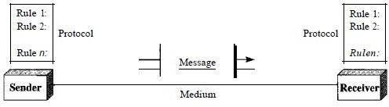

1. Message. The message is the information (data) to be communicated. Popular forms of information include text, numbers, pictures, audio, and video.
2. Sender. The sender is the device that sends the data message. It can be a computer, workstation, telephone handset, video camera, and so on.
3. Receiver. The receiver is the device that receives the message. It can be a computer, workstation, telephone handset, television, and so on.
4. Transmission medium. The transmission medium is the physical path by which a message travels from sender to receiver. Some examples of transmission media include twisted-pair wire, coaxial cable, fiber-optic cable, and radio waves
5. Protocol. A protocol is a set of rules that govern data communications. It represents an agreement between the communicating devices. Without a protocol, two devices may be connected but not communicating, just as a person speaking French cannot be understood by a person who speaks only Japanese.

## Data Representation:

Information today comes in different forms such as text, numbers, images, audio, and video.

### Text:

In data communications, text is represented as a bit pattern, a sequence of bits (Os or Is). Different sets of bit patterns have been designed to represent text symbols. Each set is called a code, and the process of representing symbols is called coding. Today, the prevalent coding system is called Unicode, which uses 32 bits to represent a symbol or character used in any language in the world. The American Standard Code for Information Interchange (ASCII), developed some decades ago in the United States, now constitutes the first 127 characters in Unicode and is also referred to as Basic Latin.

### Numbers:

Numbers are also represented by bit patterns. However, a code such as ASCII is not used to represent numbers; the number is directly converted to a binary number to simplify mathematical operations. Appendix B discusses several different numbering systems.

### Images:

Images are also represented by bit patterns. In its simplest form, an image is composed of a matrix of pixels (picture elements), where each pixel is a small dot. The size of the pixel depends on the *resolution.* For example, an image can be divided into 1000 pixels or 10,000 pixels. In the second case, there is a better representation of the image (better resolution), but more memory is needed to store the image. After an image is divided into pixels, each pixel is assigned a bit pattern. The size and the value of the pattern depend on the image. For an image made of only black and- white dots (e.g., a chessboard), a I-bit pattern is enough to represent a pixel. If an image is not made of pure white and pure black pixels, you can increase the size of the bit pattern to include gray scale. For example, to show four levels of gray scale, you can use 2-bit patterns. A black pixel can be represented by 00, a dark gray pixel by 01, a light gray pixel by 10, and a white pixel by 11. There are several methods to represent color images. One method is called RGB, so called because each color is made of a combination of three primary colors: *red,* green, and blue. The intensity of each color is measured, and a bit pattern is assigned to it. Another method is called YCM, in which a color is made of a combination of three other primary colors: yellow, cyan, and magenta.

### Audio:

Audio refers to the recording or broadcasting of sound or music. Audio is by nature

different from text, numbers, or images. It is continuous, not discrete. Even when we use a microphone to change voice or music to an electric signal, we create a continuous signal. In Chapters 4 and 5, we learn how to change sound or music to a digital or an analog signal.

*Video:*

Video refers to the recording or broadcasting of a picture or movie. Video can either be produced as a continuous entity (e.g., by a TV camera), or it can be a combination of images, each a discrete entity, arranged to convey the idea of motion. Again we can change video to a digital or an analog signal.

## Data Flow

Communication between two devices can be simplex, half-duplex, or full-duplex as shown in Figure

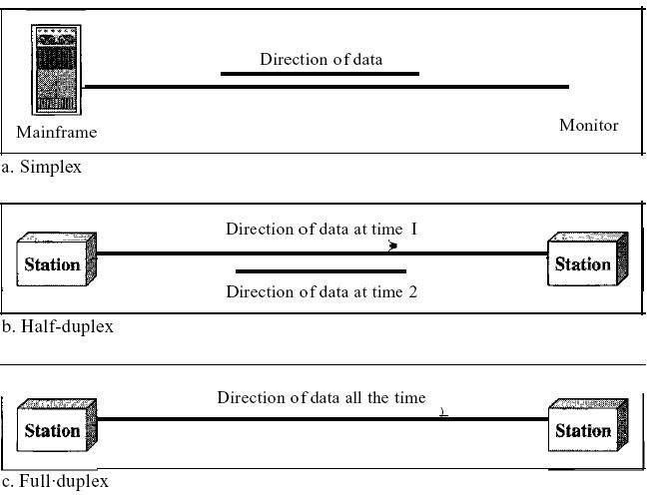

### Simplex:

In simplex mode, the communication is unidirectional, as on a one-way street. Only one of the two devices on a link can transmit; the other can only receive (see Figure a). Keyboards and traditional monitors are examples of simplex devices. The keyboard can only introduce input; the monitor can only accept output. The simplex mode can use the entire capacity of the channel to send data in one direction.

### Half-Duplex:

In half-duplex mode, each station can both transmit and receive, but not at the same time. When one device is sending, the other can only receive, and vice versa The half-duplex mode is like a one-lane road with traffic allowed in both directions.

When cars are traveling in one direction, cars going the other way must wait. In a half-duplex transmission, the entire capacity of a channel is taken over by whichever of the two devices is transmitting at the time. Walkie-talkies and CB (citizens band) radios are both half-duplex systems.

The half-duplex mode is used in cases where there is no need for communication in both directions at the same time; the entire capacity of the channel can be utilized for each direction. ***Full-Duplex:***

In full-duplex both stations can transmit and receive simultaneously (see Figure c). The full-duplex mode is like a two-way street with traffic flowing in both directions at the same time. In full-duplex mode, signals going in one direction share the capacity of the link: with signals going in the other direction. This sharing can occur in two ways: Either the link must contain two physically separate transmission paths, one for sending and the other for receiving; or the capacity of the channel is divided between signals traveling in both directions. One common example of full-duplex communication is the telephone network. When two people are communicating by a telephone line, both can talk and listen at the same time. The full-duplex mode is used when communication in both directions is required all the time. The capacity of the channel, however, must be divided between the two directions.

# NETWORKS

A network is a set of devices (often referred to as *nodes)* connected by communication links. A node can be a computer, printer, or any other device capable of sending and/or receiving data generated by other nodes on the network.

## Distributed Processing

Most networks use distributed processing, in which a task is divided among multiple computers. Instead of one single large machine being responsible for all aspects of a process, separate computers (usually a personal computer or workstation) handle a subset.

## Network Criteria

A network must be able to meet a certain number of criteria. The most important of these are performance, reliability, and security.

### Performance:

Performance can be measured in many ways, including transit time and response time.Transit time is the amount of time required for a message to travel from one device to another. Response time is the elapsed time between an inquiry and a response. The performance of a network depends on a number of factors, including the number of users, the type of transmission medium, the capabilities of the connected hardware, and the efficiency of the software. Performance is often evaluated by two networking metrics: throughput and delay. We often need more throughput and less delay. However, these two criteria are often contradictory. If we try to send more data to the network, we may increase throughput but we increase the delay because of traffic congestion in the network.

### Reliability:

In addition to accuracy of delivery, network reliability is measured by the frequency of failure, the time it takes a link to recover from a failure, and the network's robustness in a catastrophe.

### Security:

Network security issues include protecting data from unauthorized access, protecting data from damage and development, and implementing policies and procedures for recovery from breaches and data losses.

## Physical Structures:

*Type of Connection*

A network is two or more devices connected through links. A link is a communications pathway that transfers data from one device to another. For visualization purposes, it is simplest to imagine any link as a line drawn between two points. For communication to occur, two devices must be connected in some way to the same link at the same time. There are two possible types of connections: point-to-point and multipoint.

## Point-to-Point

A point-to-point connection provides a dedicated link between two devices. The entire capacity of the link is reserved for transmission between those two devices. Most point-to-point connections use an actual length of wire or cable to connect the two ends, but other options, such as microwave or satellite links, are also possible. When you change television channels by infrared remote control, you are establishing a point-to-point connection between the remote control and the television's control system.

## Multipoint

A multipoint (also called multidrop) connection is one in which more than two specific devices share a single link. In a multipoint environment, the capacity of the channel is shared, either spatially or temporally. If several devices can use the link simultaneously, it is a *spatially shared* connection. If users must take turns, it is a *timeshared* connection.

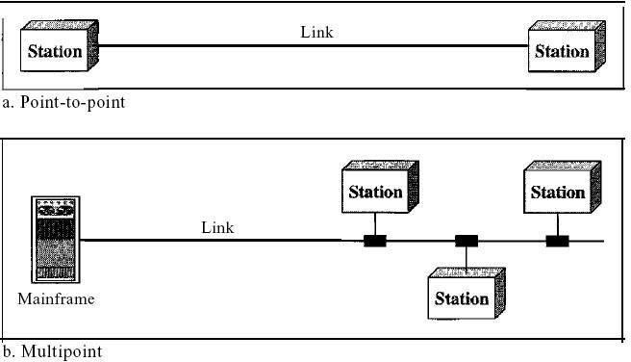

# Topologies

The term *physical topology* refers to the way in which a network is laid out physically. One or more devices connect to a link; two or more links form a topology. The topology of a network is the geometric representation of the relationship of all the links and linking devices (usually called nodes) to one another. There are four basic topologies possible: mesh, star, bus, and ring

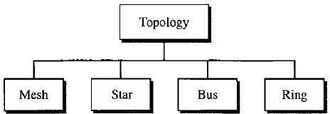

**Mesh:** In a mesh topology, every device has a dedicated point-to-point link to every other device. The term *dedicated* means that the link carries traffic only between the two devices it connects. To find the number of physical links in a fully connected mesh network with *n* nodes, we first consider that each node must be connected to every other node. Node 1 must be connected to *n* - I nodes, node 2 must be connected to *n* – 1 nodes, and finally node *n* must be connected to *n* - 1 nodes. We need *n(n* - 1) physical links. However, if each physical link allows communication in both directions (duplex mode), we can divide the number of links by 2. In other words, we can say that in a mesh topology, we need *n(n* -1) /2 duplex-mode links.

To accommodate that many links, every device on the network must have *n* – 1 input/output

*(VO)* ports to be connected to the other *n* - 1 stations.

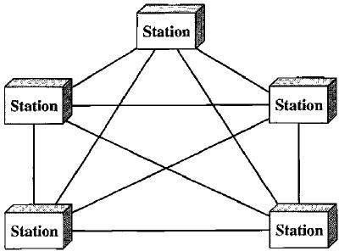

## Advantages:

* 1. The use of dedicated links guarantees that each connection can carry its own data load, thus eliminating the traffic problems that can occur when links must be shared by multiple devices.
  2. A mesh topology is robust. If one link becomes unusable, it does not incapacitate the entire system. Third, there is the advantage of privacy or security. When every message travels along a dedicated line, only the intended recipient sees it. Physical boundaries prevent other users from gaining access to messages. Finally, point-to-point links make fault identification and fault isolation easy. Traffic can be routed to avoid links with suspected problems. This facility enables the network manager to discover the precise location of the fault and aids in finding its cause and solution.

1. Disadvantage of a mesh are related to the amount of cabling because every device must be connected to every other device, installation and reconnection are difficult.
2. Second, the sheer bulk of the wiring can be greater than the available space (in walls, ceilings, or floors) can accommodate. Finally, the hardware required to connect each link (I/O ports and cable) can be prohibitively expensive.

For these reasons a mesh topology is usually implemented in a limited fashion, for example, as a backbone connecting the main computers of a hybrid network that can include several other topologies.

## Star Topology:

In a star topology, each device has a dedicated point-to-point link only to a central controller, usually called a hub. The devices are not directly linked to one another. Unlike a mesh topology, a star topology does not allow direct traffic between devices. The controller acts as an exchange: If one device wants to send data to another, it sends the data to the controller, which then relays the data to the other connected device .

A star topology is less expensive than a mesh topology. In a star, each device needs only one link and one I/O port to connect it to any number of others. This factor also makes it easy to install and reconfigure. Far less cabling needs to be housed, and additions, moves, and deletions involve only one connection: between that device and the hub.

Other advantages include robustness. If one link fails, only that link is affected. All other links remain active. This factor also lends itself to easy fault identification and fault isolation. As long as the hub is working, it can be used to monitor link problems and bypass defective links.

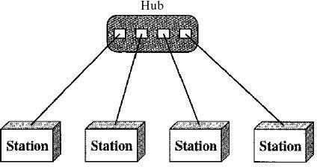

One big disadvantage of a star topology is the dependency of the whole topology on one single point, the hub. If the hub goes down, the whole system is dead. Although a star requires far less cable than a mesh, each node must be linked to a central hub. For this reason, often more cabling is required in a star than in some other topologies (such as ring or bus).

## Bus Topology:

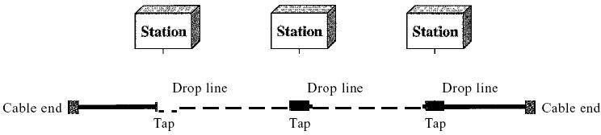The preceding examples all describe point-to-point connections. A **bus topology,** on the other hand, is multipoint. One long cable acts as a **backbone** to link all the devices in a network

Nodes are connected to the bus cable by drop lines and taps. A drop line is a connection running between the device and the main cable. A tap is a connector that either splices into the main cable or punctures the sheathing of a cable to create a contact with the metallic core. As a signal travels along the backbone, some of its energy is transformed into heat. Therefore, it becomes weaker and weaker as it travels farther and farther. For this reason there is a limit on the number of taps a bus can support and on the distance between those taps.

**Y.N.S.Satyanarayana,Asst.Prof,CSE**

Advantages of a bus topology include ease of installation. Backbone cable can be laid along the most efficient path, then connected to the nodes by drop lines of various lengths. In this way, a bus uses less cabling than mesh or star topologies. In a star, for example, four network devices in the same room require four lengths of cable reaching all the way to the hub. In a bus, this redundancy is eliminated. Only the backbone cable stretches through the entire facility. Each drop line has to reach only as far as the nearest point on the backbone.

Disadvantages include difficult reconnection and fault isolation. A bus is usually designed to be optimally efficient at installation. It can therefore be difficult to add new devices. Signal reflection at the taps can cause degradation in quality. This degradation can be controlled by limiting the number and spacing of devices connected to a given length of cable. Adding new devices may therefore require modification or replacement of the backbone.

In addition, a fault or break in the bus cable stops all transmission, even between devices on the same side of the problem. The damaged area reflects signals back in the direction of origin, creating noise in both directions.

Bus topology was the one of the first topologies used in the design of early local area networks. Ethernet LANs can use a bus topology, but they are less popular.

Ring Topology In a ring topology, each device has a dedicated point-to-point connection with only the two devices on either side of it. A signal is passed along the ring in one direction, from device to device, until it reaches its destination. Each device in the ring incorporates a repeater. When a device receives a signal intended for another device, its repeater regenerates the bits and passes them along

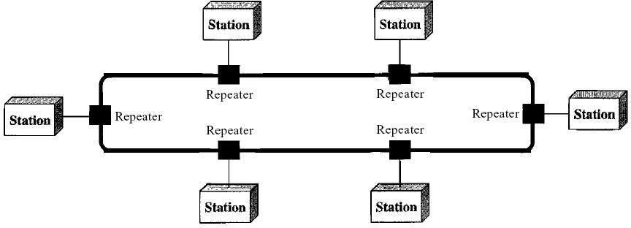

A ring is relatively easy to install and reconfigure. Each device is linked to only its immediate neighbors (either physically or logically). To add or delete a device requires changing only two connections. The only constraints are media and traffic considerations (maximum ring length and number of devices). In addition, fault isolation is simplified. Generally in a ring, a signal is circulating at all times. If one device does not receive a signal within a specified period, it can issue an alarm. The alarm alerts the network operator to the problem and its location.

However, unidirectional traffic can be a disadvantage. In a simple ring, a break in the ring (such as a disabled station) can disable the entire network. This weakness can be solved by using a dual ring or a switch capable of closing off the break. Ring topology was prevalent when IBM introduced its local-area network Token Ring. Today, the need for higher-speed LANs has made this topology less popular. Hybrid Topology A network can be hybrid. For example, we can have a main star topology with each branch connecting several stations in a bus topology as shown in Figure

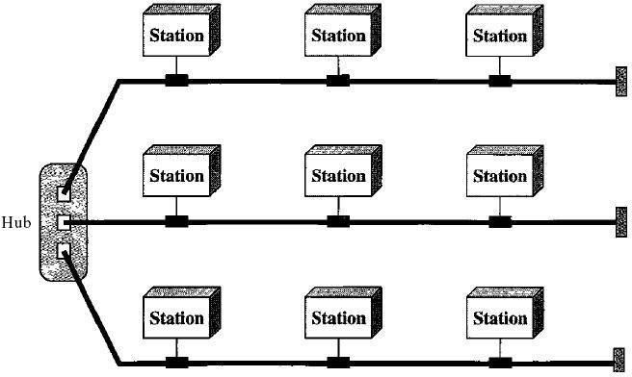

# Categories of Networks

## Local Area Networks:

Local area networks, generally called LANs, are privately-owned networks within a single building or campus of up to a few kilometres in size. They are widely used to connect personal computers and workstations in company offices and factories to share resources (e.g., printers) and exchange information. LANs are distinguished from other kinds of networks by three characteristics:

1. Their size,
2. Their transmission technology, and
3. Their topology.

LANs are restricted in size, which means that the worst-case transmission time is bounded and known in advance. Knowing this bound makes it possible to use certain kinds of designs that would not otherwise be possible. It also simplifies network management. LANs may use a transmission technology consisting of a cable to which all the machines are attached, like the telephone company party lines once used in rural areas. Traditional LANs run at speeds of 10 Mbps to 100 Mbps, have low delay (microseconds or nanoseconds), and make very few errors. Newer LANs operate at up to 10 Gbps Various topologies are possible for broadcast LANs. Figure1 shows two of them. In a bus (i.e., a linear cable) network, at any instant at most one machine is the master and is allowed to transmit. All other machines are required to refrain from sending. An arbitration mechanism is needed to resolve conflicts when two or more machines want to transmit simultaneously. The arbitration mechanism may be centralized or distributed. IEEE 802.3, popularly called Ethernet, for example, is a bus-based broadcast network with decentralized control, usually operating at 10 Mbps to 10 Gbps. Computers on an Ethernet can transmit whenever they want to; if two or more packets collide, each computer just waits a random time and tries again later.

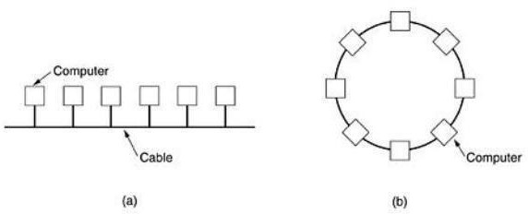

## Fig: Two broadcast networks . (a) Bus. (b) Ring.

A second type of broadcast system is the ring. In a ring, each bit propagates around on its own, not waiting for the rest of the packet to which it belongs. Typically, each bit circumnavigates the entire ring in the time it takes to transmit a few bits, often before the complete packet has even been transmitted. As with all other broadcast systems, some rule is needed for arbitrating simultaneous accesses to the ring. Various methods, such as having the machines take turns, are in use. IEEE 802.5 (the IBM token ring), is a ring-based LAN operating at 4 and 16 Mbps. FDDI is another example of a ring network.

## Metropolitan Area Network (MAN):

**Metropolitan Area Network:**

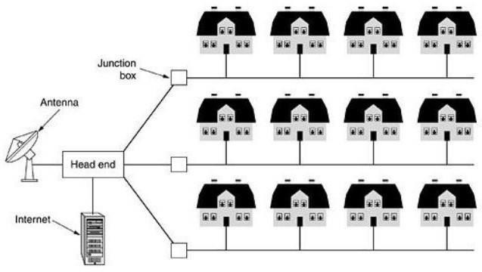A metropolitan area network, or MAN, covers a city. The best-known example of a MAN is the cable television network available in many cities. This system grew from earlier community antenna systems used in areas with poor over-the-air television reception. In these early systems, a large antenna was placed on top of a nearby hill and signal was then piped to the subscribers' houses. At first, these were locally-designed, ad hoc systems. Then companies began jumping into the business, getting contracts from city governments to wire up an entire city. The next step was television programming and even entire channels designed for cable only. Often these channels were highly specialized, such as all news, all sports, all cooking, all gardening, and so on. But from their inception until the late 1990s, they were intended for television reception only. To a first approximation, a MAN might look something like the system shown in Fig. In this figure both television signals and Internet are fed into the centralized head end for subsequent distribution to people's homes. Cable television is not the only MAN. Recent developments in high-speed wireless Internet access resulted in another MAN, which has been standardized as IEEE 802.16.

## Fig: Metropolitan area network based on cable TV.

A MAN is implemented by a standard called DQDB (Distributed Queue Dual Bus) or IEEE 802.16. DQDB has two unidirectional buses (or cables) to which all the computers are attached.

## Wide Area Network (WAN). Wide Area Network:

A wide area network, or WAN, spans a large geographical area, often a country or continent. It contains a collection of machines intended for running user (i.e., application) programs. These machines are called as hosts. The hosts are connected by a communication subnet, or just subnet for short. The hosts are owned by the customers (e.g., people's personal computers), whereas the communication subnet is typically owned and operated by a telephone company or Internet service provider. The job of the subnet is to carry messages from host to host, just as the telephone system carries words from speaker to listener.

Separation of the pure communication aspects of the network (the subnet) from the application aspects (the hosts), greatly simplifies the complete network design. In most wide area networks, the subnet consists of two distinct components: transmission lines and switching elements.

Transmission lines move bits between machines. They can be made of copper wire, optical fiber, or even radio links. In most WANs, the network contains numerous transmission lines, each one connecting a pair of routers. If two routers that do not share a transmission line wish to communicate, they must do this indirectly, via other routers. When a packet is sent from one router to another via one or more intermediate routers, the packet is received at each intermediate router in its entirety, stored there until the required output line is free, and then forwarded. A subnet organized according to this principle is called a store-and-forward or packet-switched subnet. Nearly all wide area networks (except those using satellites) have store-and-forward subnets. When the packets are small and all the same size, they are often called cells.

The principle of a packet-switched WAN is so important. Generally, when a process on some host has a message to be sent to a process on some other host, the sending host first cuts the message into packets, each one bearing its number in the sequence. These packets are then injected into the network one at a time in quick succession. The packets are transported individually over the network and deposited at the receiving host, where they are reassembled into the original message and delivered to the receiving process. A stream of packets resulting from some initial message is illustrated in Fig.

In this figure, all the packets follow the route ACE, rather than ABDE or ACDE. In some networks all packets from a given message must follow the same route; in others each packed is routed separately. Of course, if ACE is the best route, all packets may be sent along it, even if each packet is individually routed.

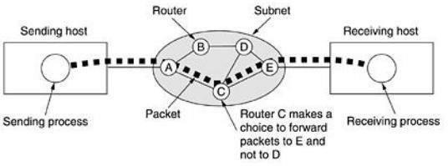

## Fig: A stream of packets from sender to receiver.

Not all WANs are packet switched. A second possibility for a WAN is a satellite system. Each router has an antenna through which it can send and receive. All routers can hear the output from the satellite, and in some cases they can also hear the upward transmissions of their fellow routers to the satellite as well. Sometimes the routers are connected to a substantial point-to-point subnet, with only some of them having a satellite antenna. Satellite networks are inherently broadcast and are most useful when the broadcast property is important.

# Examples of Networks

**Novell NetWare**

**Novell NetWare** is type of Network Operating System. It provides wide networking services ranging from easy and simple file to network user, data, security, and even resource management. It is generally designed for networks or Local Area Network (LAN) operating system.

**Novell NetWare** is most popular and widely used network system in PC world. Novell NetWare is simply designed to get used by various companies downsizing from mainframe to network of PCs. It only needs low hardware requirements and has memory protection. It keeps safe and protects single processes from each other. Novell NetWare is discontinued network operating system basically developed by Novell, Inc.

In today’s market, it is one of most powerful networks operating systems. It generally uses

proprietary protocol stack as shown in below diagram. Novell NetWare 6.5 is one of Novell’s most current network operating system used nowadays.

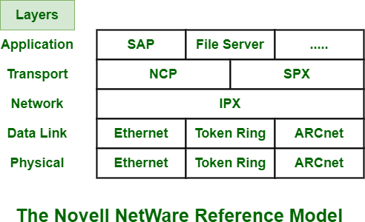

## Protocols in Novell Netware :

* **Internet Package Exchange (IPX) –**

Network layer generally runs unreliable connectionless internetwork protocol. It is called Internet Package Exchange (IPX) protocol. This protocol is simply used for routing and showing path to packets to move from one network node to another network throughout internetwork.

Format of IPX is shown below:

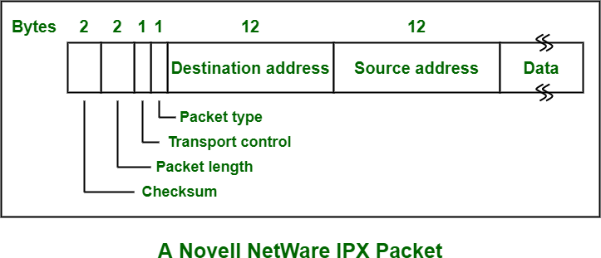

## NetWare Core Protocol (NCP) –

NCP is type of network protocol that is used in many products from Novell, Inc. It is actually Novell client-server protocol used for mainly Local Area Network (LAN). It is generally connected to NetWare Operating systems (OS). It also works with alternating operating systems along with UNIX, Linux, and Windows NT.

## Sequenced Packet Exchange (SPX) –

SPX is also type of network protocol that is used by Novell Netware. SPX is also supported by other operating systems. It is nowadays considered legacy protocol as it has largely been replaced by TCP/IP. This protocol is simply used for handling packet sequencing in Novell Netware network.

## Features of Novell Netware :

Most important features of Netware are following:

## Directory Service –

Novell Directory Service (NDS) is distributed directory service mainly used for managing network resources such as users, servers, and peripherals. It is originally known as NetWare Directory Services. It uses NDS for resource access and authentication.

Directory service of networking operating system allows and enables users to identify and find network resources that are required. There are basically three types of Directory services of Novell Netware such as Bindery, NDS, EDirectory.

## User Interface –

It contains simple user interface by which user and computer system can interact in easy way.

## Hardware requirements –

This network operating system does not require or needs many hardware devices. It needs very minimal hardware devices.

## Interoperability –

Using this networking operating system, ability of computer systems or software to simply exchange and make use of information with many types of computer systems is increased.

**ARPANET**

**ARPANET** stands for **Advanced Research Projects Agency NET**. ARPANET was first network which consisted of distributed control. It was first to implement TCP/IP protocols. It was basically beginning of Internet with use of these technologies. It was designed with a basic idea in mind that was to communicate with scientific users among an institute or university.

## History of ARPANET :

ARPANET was introduced in the year 1969 by Advanced Research Projects Agency (ARPA) of US Department of Defense. It was established using a bunch of PCs at various colleges and sharing of information and messages was done. It was for playing as long separation diversions and individuals were asked to share their perspectives. In the year 1980, ARPANET was handed over to different military network, Defense Data Network.

## Characteristics of ARPANET :

* 1. It is basically a type of WAN.
  2. It used concept of Packet Switching Network.
  3. It used Interface Message Processors(IMPs) for sub-netting.
  4. ARPANETs software was split into two parts- a host and a subnet.

## Advantages of ARPANET :

* + ARPANET was designed to service even in a Nuclear Attack.
  + It was used for collaborations through E-mails.
  + It created an advancement in transfer of important files and data of defense.

## Limitations of ARPANET :

* + Increased number of LAN connections resulted in difficulty handling.
  + It was unable to cope-up with advancement in technology.

**THE INTERNET**

The Internet has revolutionized many aspects of our daily lives. It has affected the way we do business as well as the way we spend our leisure time. Count the ways you've used the Internet recently. Perhaps you've sent electronic mail (e-mail) to a business associate, paid a utility bill, read a newspaper from a distant city, or looked up a local movie schedule-all by using the Internet. Or maybe you researched a medical topic, booked a hotel reservation, chatted with a fellow Trekkie, or comparison-shopped for a car. The Internet is a communication system that has brought a wealth of information to our fingertips and organized it for our use.

## A Brief History

A network is a group of connected communicating devices such as computers and printers. An internet (note the lowercase letter i) is two or more networks that can communicate with each other. The most notable internet is called the Internet (uppercase letter I), a collaboration of more than hundreds of thousands of interconnected networks. Private individuals as well as various organizations such as government agencies, schools, research facilities, corporations, and libraries in more than 100 countries use the Internet. Millions of people are users. Yet this extraordinary communication system only came into being in 1969.

In the mid-1960s, mainframe computers in research organizations were standalone devices. Computers from different manufacturers were unable to communicate with one another. The Advanced Research Projects Agency (ARPA) in the Department of Defense (DoD) was interested in finding a way to connect computers so that the researchers they funded could share their findings, thereby reducing costs and eliminating duplication of effort.

In 1967, at an Association for Computing Machinery (ACM) meeting, ARPA presented its ideas for ARPANET, a small network of connected computers. The idea was that each host computer (not necessarily from the same manufacturer) would be attached to a specialized computer, called an *inteiface message processor* (IMP). The IMPs, in tum, would be connected to one another. Each IMP had to be able to communicate with other IMPs as well as with its own attached host. By 1969, ARPANET was a reality. Four nodes, at the University of California at Los Angeles (UCLA), the University of California at Santa Barbara (UCSB), Stanford Research Institute (SRI), and the University of Utah, were connected via the IMPs to form a network. Software called the *Network Control Protocol* (NCP) provided communication between the hosts.

In 1972, Vint Cerf and Bob Kahn, both of whom were part of the core ARPANET group,

collaborated on what they called the *Internetting Project.* Cerf and Kahn's landmark 1973 paper outlined the protocols to achieve end-to-end delivery of packets. This paper on Transmission Control Protocol (TCP) included concepts such as encapsulation, the datagram, and the functions of a gateway. Shortly thereafter, authorities made a decision to split TCP into two protocols:

Transmission Control Protocol datagram routing while TCP

(TCP) and Internetworking Protocol (lP). IP would handle would be responsible for higher-level functions such as

segmentation, reassembly, and error detection. The internetworking protocol became known as TCPIIP.

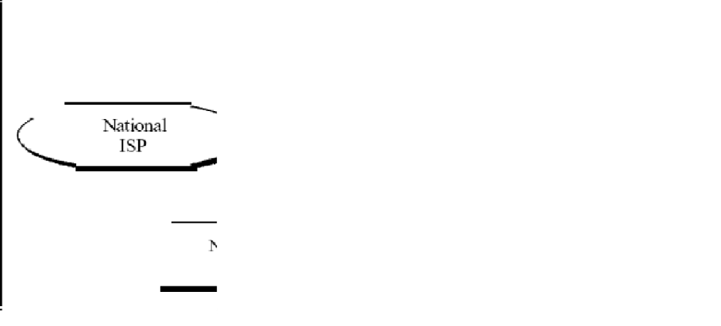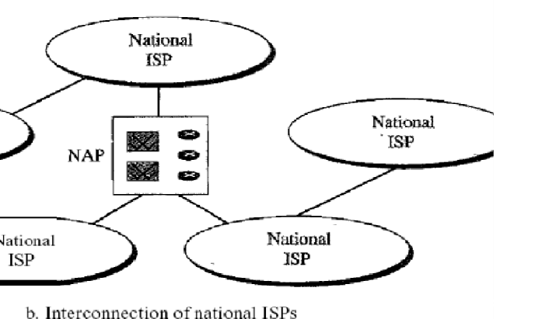

## The Internet Today

The Internet has come a long way since the 1960s. The Internet today is not a simple hierarchical structure. It is made up of many wide- and local-area networks joined by connecting devices and switching stations. It is difficult to give an accurate representation of the Internet because it is continually changing-new networks are being added, existing networks are adding addresses, and networks of defunct companies are being removed. Today most end users who want Internet connection use the services of Internet service providers (lSPs). There are international service providers, national service providers, regional service providers, and local service providers. The Internet today is run by private companies, not the government. Figure 1.13 shows a conceptual (not geographic) view of the Internet.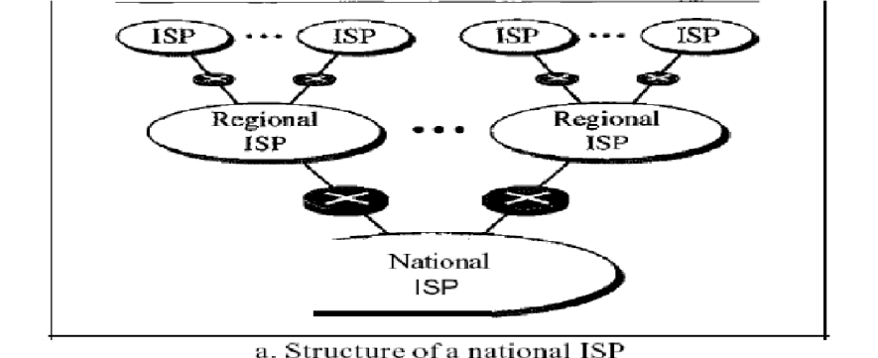

### International Internet Service Providers:

At the top of the hierarchy are the international service providers that connect nations together.

### National Internet Service Providers:

The national Internet service providers are backbone networks created and maintained by specialized companies. There are many national ISPs operating in North America; some of the most well known are SprintLink, PSINet, UUNet Technology, AGIS, and internet Mel. To provide connectivity between the end users, these backbone networks are connected by complex switching stations (normally run by a third party) called network access points (NAPs). Some national ISP networks are also connected to one another by private switching stations called *peering points.* These normally operate at a high data rate (up to 600 Mbps).

### Regional Internet Service Providers:

Regional internet service providers or regional ISPs are smaller ISPs that are connected to one or more national ISPs. They are at the third level of the hierarchy with a smaller data rate. ***Local Internet Service Providers:***

Local Internet service providers provide direct service to the end users. The local ISPs can be connected to regional ISPs or directly to national ISPs. Most end users are connected to the local ISPs. Note that in this sense, a local ISP can be a company that just provides Internet services, a corporation with a network that supplies services to its own employees, or a nonprofit organization, such as a college or a university, that runs its own network. Each of these local ISPs can be connected to a regional or national service provider.

# PROTOCOLS AND STANDARDS

## Protocols:

In computer networks, communication occurs between entities in different systems. An entity is anything capable of sending or receiving information. However, two entities cannot simply send bit streams to each other and expect to be understood. For communication to occur, the entities must agree on a protocol. A protocol is a set of rules that govern data communications. A protocol defines what is communicated, how it is communicated, and when it is communicated. The key elements of a protocol are syntax, semantics, and timing.

* **Syntax:** The term *syntax* refers to the structure or format of the data, meaning the order in which they are presented. For example, a simple protocol might expect the first 8 bits of data to be the address of the sender, the second 8 bits to be the address of the receiver, and the rest of the stream to be the message itself.
* **Semantics:** The word *semantics* refers to the meaning of each section of bits. How is a particular pattern to be interpreted, and what action is to be taken based on that interpretation? For example, does an address identify the route to be taken or the final destination of the message?
* **Timing:** The term *timing* refers to two characteristics: when data should be sent and how fast they can be sent. For example, if a sender produces data at 100 Mbps but the receiver can process data at only 1 Mbps, the transmission will overload the receiver and some data will be lost.

## Standards

Standards are essential in creating and maintaining an open and competitive market for equipment manufacturers and in guaranteeing national and international interoperability of data and telecommunications technology and processes. Standards provide guidelines to manufacturers, vendors, government agencies, and other service providers to ensure the kind of interconnectivity necessary in today's marketplace and in international communications.

Data communication standards fall into two categories: *de facto* (meaning "by fact" or "by convention") and *de jure* (meaning "by law" or "by regulation").

* De facto. Standards that have not been approved by an organized body but have been adopted as standards through widespread use are de facto standards. De facto standards are often established originally by manufacturers who seek to define the functionality of a new product or technology.
* De jure. Those standards that have been legislated by an officially recognized body are de jure standards.

## LAYERED TASKS

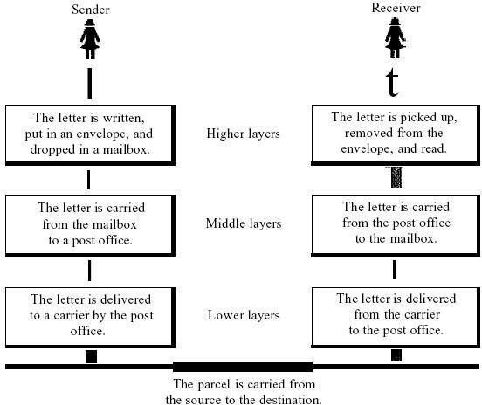We use the concept of layers in our daily life. As an example, let us consider two friends who communicate through postal maiL The process of sending a letter to a friend would be complex if there were no services available from the post office. Below Figure shows the steps in this task.

Sender, Receiver, and Carrier

In Figure we have a sender, a receiver, and a carrier that transports the letter. There is a hierarchy of tasks.

*At the Sender Side*

Let us first describe, in order, the activities that take place at the sender side.

* Higher layer. The sender writes the letter, inserts the letter in an envelope, writes the sender and receiver addresses, and drops the letter in a mailbox.
* Middle layer. The letter is picked up by a letter carrier and delivered to the post office.
* Lower layer. The letter is sorted at the post office; a carrier transports the letter.

*0n the Way:* The letter is then on its way to the recipient. On the way to the recipient's local post office, the letter may actually go through a central office. In addition, it may be transported by truck, train, airplane, boat, or a combination of these.

*At the Receiver Side*

* Lower layer. The carrier transports the letter to the post office.
* Middle layer. The letter is sorted and delivered to the recipient's mailbox.
* Higher layer. The receiver picks up the letter, opens the envelope, and reads it.

# The OSI Reference Model:

The OSI model (minus the physical medium) is shown in Fig. This model is based on a proposal developed by the International Standards Organization (ISO) as a first step toward international standardization of the protocols used in the various layers (Day and Zimmermann, 1983). It was revised in 1995(Day, 1995). The model is called the ISO-OSI (Open Systems Interconnection) Reference Model because it deals with connecting open systems—that is, systems that are open for communication with other systems.

The OSI model has seven layers. The principles that were applied to arrive at the seven layers can be briefly summarized as follows:

1. A layer should be created where a different abstraction is needed.
2. Each layer should perform a well-defined function.
3. The function of each layer should be chosen with an eye toward defining internationally standardized protocols.
4. The layer boundaries should be chosen to minimize the information flow across the interfaces.
5. The number of layers should be large enough that distinct functions need not be thrown together in the same layer out of necessity and small enough that the architecture does not become unwieldy.

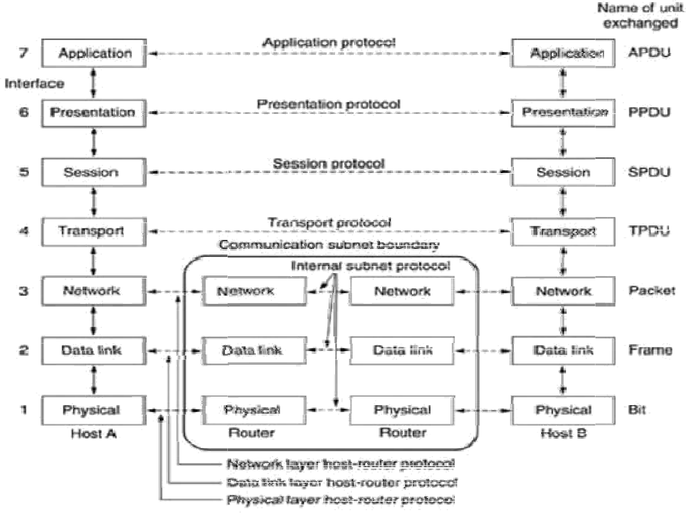

**.**

**CN-UNIT-1 Y.N.S.Satyanarayana,Asst.Prof,CSE**

## The Physical Layer:

## The physical layer is concerned with transmitting raw bits over a communication channel. The design issues have to do with making sure that when one side sends a 1 bit, it is received by the other side as a 1 bit, not as a 0 bit.

## 

## The Data Link Layer:

The main task of the data link layer is to transform a raw transmission facility into a line that appears free of undetected transmission errors to the network layer. It accomplishes this task by having the sender break up the input data into data frames (typically a few hundred or a few thousand bytes) and transmits the frames sequentially. If the service is reliable, the receiver confirms correct receipt of each frame by sending back an acknowledgement frame.

Another issue that arises in the data link layer (and most of the higher layers as well) is how to keep a fast transmitter from drowning a slow receiver in data. Some traffic regulation mechanism is often needed to let the transmitter know how much buffer space the receiver has at the moment. Frequently, this flow regulation and the error handling are integrated.

## The Network Layer:

The network layer controls the operation of the subnet. A key design issue is determining how packets are routed from source to destination. Routes can be based on static tables that are ''wired into'' the network and rarely changed. They can also be determined at the start of each conversation, for example, a terminal session (e.g., a login to a remote machine). Finally, they can be highly dynamic, being determined anew for each packet, to reflect the current network load.

If too many packets are present in the subnet at the same time, they will get in one another's way, forming bottlenecks. The control of such congestion also belongs to the network layer. More generally, the quality of service provided (delay, transit time, jitter, etc.) is also a network layer issue.

When a packet has to travel from one network to another to get to its destination, many problems can arise. The addressing used by the second network may be different from the first one. The second one may not accept the packet at all because it is too large. The protocols may differ, and so on. It is up to the network layer to overcome all these problems to allow heterogeneous networks to be interconnected. In broadcast networks, the routing problem is simple, so the network layer is often thin or even nonexistent.

## The Transport Layer:

The basic function of the transport layer is to accept data from above, split it up into smaller units if need be, pass these to the network layer, and ensure that the pieces all arrive correctly at the other end. Furthermore, all this must be done efficiently and in a way that isolates the upper layers from the inevitable changes in the hardware technology. The transport layer also determines what type of service to provide to the session layer, and, ultimately, to the users of the network. The most popular type of transport connection is an error-free point-to-point channel that delivers messages or bytes in the order in which they were sent. However, other possible kinds of transport service are the transporting of isolated messages, with no guarantee about the order of delivery, and the broadcasting of messages to multiple destinations. The type of service is determined when the connection is established.

The transport layer is a true end-to-end layer, all the way from the source to the destination. In other words, a program on the source machine carries on a conversation with a similar program on the destination machine, using the message headers and control messages. In the lower layers,

the protocols are between each machine and its immediate neighbours, and not between the ultimate source and destination machines, which may be separated by many routers.

## The Session Layer:

The session layer allows users on different machines to establish sessions between them. Sessions offer various services, including dialog control (keeping track of whose turn it is to transmit), token management (preventing two parties from attempting the same critical operation at the same time), and synchronization (check pointing long transmissions to allow them to continue from where they were after a crash).

## The Presentation Layer:

The presentation layer is concerned with the syntax and semantics of the information transmitted. In order to make it possible for computers with different data representations to communicate, the data structures to be exchanged can be defined in an abstract way, along with a standard encoding to be used ''on the wire.'' The presentation layer manages these abstract data structures and allows higher-level data structures (e.g., banking records), to be defined and exchanged.

## The Application Layer:

The application layer contains a variety of protocols that are commonly needed by users. One widely-used application protocol is HTTP (Hypertext Transfer Protocol), which is the basis for the World Wide Web. When a browser wants a Web page, it sends the name of the page it wants to the server using HTTP. The server then sends the page back. Other application protocols are used for file transfer, electronic mail, and network news.

# The TCP/IP Reference Model:

The TCP/IP reference model was developed prior to OSI model. The major design goals of this model were,

1. To connect multiple networks together so that they appear as a single network.
2. To survive after partial subnet hardware failures.
3. To provide a flexible architecture.

Unlike OSI reference model, TCP/IP reference model has only 4 layers. They are,

1. Host-to-Network Layer
2. Internet Layer
3. Transport Layer
4. Application Layer Application Layer Transport Layer Internet Layer Host-to- Network Layer

## Host-to-Network Layer:

The TCP/IP reference model does not really say much about what happens here, except to point out that the host has to connect to the network using some protocol so it can send IP packets to it. This protocol is not defined and varies from host to host and network to network.

## Internet Layer:

This layer, called the internet layer, is the linchpin that holds the whole architecture together. Its job is to permit hosts to inject packets into any network and have they travel independently to the destination (potentially on a different network). They may even arrive in a different order than they were sent, in which case it is the job of higher layers to rearrange them, if in-order delivery is desired. Note that ''internet'' is used here in a generic sense, even though this layer is present in the Internet.

The internet layer defines an official packet format and protocol called IP (Internet Protocol). The job of the internet layer is to deliver IP packets where they are supposed to go. Packet routing is clearly the major issue here, as is avoiding congestion. For these reasons, it is reasonable to say that the TCP/IP internet layer is similar in functionality to the OSI network layer. Fig. shows this correspondence.

## The Transport Layer:

The layer above the internet layer in the TCP/IP model is now usually called the transport layer. It is designed to allow peer entities on the source and destination hosts to carry on a conversation, just as in the OSI transport layer. Two end-to-end transport protocols have been defined here. The first one, TCP (Transmission Control Protocol), is a reliable connection- oriented protocol that allows a byte stream originating on one machine to be delivered without error on any other machine in the internet. It fragments the incoming byte stream into discrete messages and passes each one on to the internet layer. At the destination, the receiving TCP process reassembles the received messages into the output stream. TCP also handles flow control

to make sure a fast sender cannot swamp a slow receiver with more messages than it can handle.

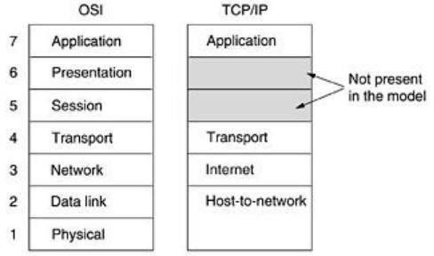

## Fig: The TCP/IP reference model.

The second protocol in this layer, UDP (User Datagram Protocol), is an unreliable, connectionless protocol for applications that do not want TCP's sequencing or flow control and wish to provide their own. It is also widely used for one-shot, client-server-type request-reply queries and applications in which prompt delivery is more important than accurate delivery, such as transmitting speech or video. The relation of IP, TCP, and UDP is shown in Fig.2. Since the model was developed, IP has been implemented on many other networks.

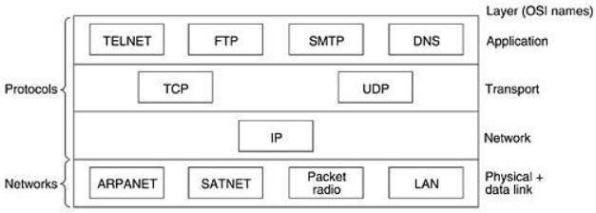

## Fig: Protocols and networks in the TCP/IP model initially.

**The Application Layer:**

The TCP/IP model does not have session or presentation layers. On top of the transport layer is the application layer. It contains all the higher-level protocols. The early ones included virtual terminal (TELNET), file transfer (FTP), and electronic mail (SMTP), as shown in Fig.6.2. The virtual terminal protocol allows a user on one machine to log onto a distant machine and work there. The file transfer protocol provides a way to move data efficiently from one machine to another. Electronic mail was originally just a kind of file transfer, but later a specialized protocol (SMTP) was developed for it. Many other protocols have been added to these over the years: the Domain Name System (DNS) for mapping host names onto their network addresses, NNTP, the protocol for moving USENET news articles around, and HTTP, the protocol for fetching pages on the World Wide Web, and many others.

# Comparison of the OSI and TCP/IP Reference Models:

The OSI and TCP/IP reference models have much in common. Both are based on the concept of a stack of independent protocols. Also, the functionality of the layers is roughly similar. For example, in both models the layers up through and including the transport layer are there to provide an end-to-end, network-independent transport service to processes wishing to communicate. These layers form the transport provider. Again in both models, the layers above transport are application-oriented users of the transport service. Despite these fundamental similarities, the two models also have many differences Three concepts are central to the OSI model:

1. Services.
2. Interfaces.
3. Protocols.

Probably the biggest contribution of the OSI model is to make the distinction between these three concepts explicit. Each layer performs some services for the layer above it. The service definition tells what the layer does, not how entities above it access it or how the layer works. It defines the layer's semantics.

A layer's interface tells the processes above it how to access it. It specifies what the parameters are and what results to expect. It, too, says nothing about how the layer works inside.

Finally, the peer protocols used in a layer are the layer's own business. It can use any protocols it wants to, as long as it gets the job done (i.e., provides the offered services). It can also change them at will without affecting software in higher layers.

The TCP/IP model did not originally clearly distinguish between service, interface, and protocol, although people have tried to retrofit it after the fact to make it more OSI-like. For example, the only real services offered by the internet layer are SEND IP PACKET and RECEIVE IP PACKET.

As a consequence, the protocols in the OSI model are better hidden than in the TCP/IP model and can be replaced relatively easily as the technology changes. Being able to make such changes is one of the main purposes of having layered protocols in the first place. The OSI reference model was devised before the corresponding protocols were invented. This ordering means that the model was not biased toward one particular set of protocols, a fact that made it quite general. The downside of this ordering is that the designers did not have much experience with the subject and did not have a good idea of which functionality to put in which layer.

Another difference is in the area of connectionless versus connection-oriented communication. The OSI model supports both connectionless and connection-oriented communication in the network layer, but only connection-oriented communication in the transport layer, where it counts (because the transport service is visible to the users). The TCP/IP model has only one mode in the network layer (connectionless) but supports both modes in the transport layer, giving the users a choice. This choice is especially important for simple request-response protocols.

|  |  |
| --- | --- |
| **OSI(Open System Interconnection)** | **TCP/IP(Transmission Control Protocol / Internet Protocol)** |
| 1. OSI is a generic, protocol independent standard, acting as a communication gateway between the network and end user. | 1. TCP/IP model is based on standard protocols around which the Internet has developed. It is a communication protocol, which allows connection of hosts over a network. |
| 2. In OSI model the transport layer guarantees the delivery of packets. | 2. In TCP/IP model the transport layer does not guarantees delivery of packets. Still the TCP/IP model is more reliable. |
| 3. Follows vertical approach. | 3. Follows horizontal approach. |
| 4. OSI model has a separate Presentation layer and Session layer. | 4. TCP/IP does not have a separate Presentation layer or Session layer. |
| 5. Transport Layer is Connection Oriented. | 5. Transport Layer is both Connection Oriented and Connection less. |
| 6. Network Layer is both Connection Oriented and Connection less. | 6. Network Layer is Connection less. |
| 7. OSI is a reference model around which  the networks are built. Generally it is used as a guidance tool. | 7. TCP/IP model is, in a way implementation of the OSI model. |
| 8. Network layer of OSI model provides  both connection oriented and connectionless service. | 8. The Network layer in TCP/IP model provides connectionless service. |
| 9. OSI model has a problem of fitting the protocols into the model. | 9. TCP/IP model does not fit any protocol |
| 10. Protocols are hidden in OSI model and are easily replaced. | 10. In TCP/IP replacing protocol is not easy. |
| 11. OSI model defines services, interfaces and protocols very clearly and makes clear distinction between them. It is protocol independent. | 11. In TCP/IP, services, interfaces and protocols are not clearly separated. It is also protocol dependent. |
| 12. It has 7 layers | 12. It has 4 layers |

# Transmission Media

For any networking to be effective, raw stream of data is to be transported from one device to other over some medium. Various transmission media can be used for transfer of data. These transmission media may be of two types −

* **Guided** − In guided media, transmitted data travels through cabling system that has a fixed path. For example, copper wires, fibre optic wires, etc.
* **Unguided** − In unguided media, transmitted data travels through free space in form of electromagnetic signal. For example, radio waves, lasers, etc.

Each transmission media has its own advantages and disadvantages in terms of bandwidth, speed, delay, cost per bit, ease of installation and maintenance, etc. Let’s discuss some of the most commonly used media in detail.

## Twisted Pair Cable

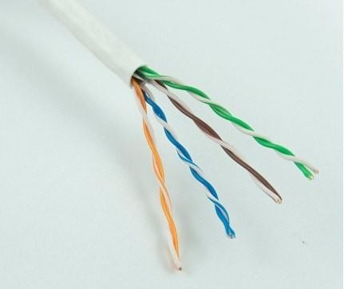Copper wires are the most common wires used for transmitting signals because of good performance at low costs. They are most commonly used in telephone lines. However, if two or more wires are lying together, they can interfere with each other’s signals.

To reduce this electromagnetic interference, pair of copper wires are twisted together in helical shape like a DNA molecule. Such twisted copper wires are called **twisted pair**. To reduce interference between nearby twisted pairs, the twist rates are different for each pair. Up to 25 twisted pair are put together in a protective covering to form twisted pair cables that are the backbone of telephone systems and Ethernet networks.

## Advantages of twisted pair cable

Twisted pair cables are the oldest and most popular cables all over the world. This is due to the many advantages that they offer −

* Trained personnel easily available due to shallow learning curve
* Can be used for both analog and digital transmissions
* Least expensive for short distances
* Entire network does not go down if a part of network is damaged

## Disadvantages of twisted pair cable

With its many advantages, twisted pair cables offer some disadvantages too −

* Signal cannot travel long distances without repeaters
* High error rate for distances greater than 100m
* Very thin and hence breaks easily
* Not suitable for broadband connections

## Coaxial Cable

**Coaxial cables** are copper cables with better **shielding** than twisted pair cables, so that transmitted signals may travel longer distances at higher speeds. A coaxial cable consists of these layers, starting from the innermost −

* Stiff copper wire as **core**
* **Insulating material** surrounding the core
* Closely woven braided mesh of **conducting material** surrounding the **insulator**
* Protective **plastic sheath** encasing the wire

Coaxial cables are widely used for **cable TV** connections and **LANs**.

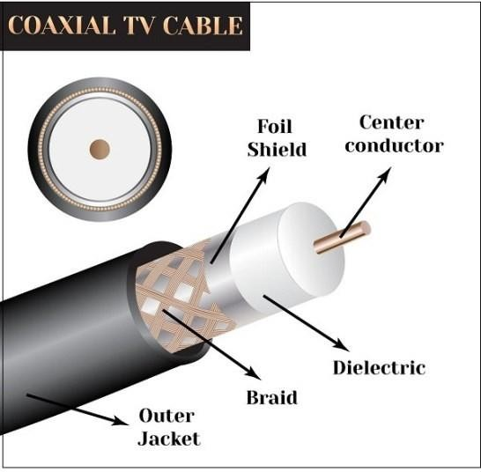

## Advantages of Coaxial Cables

* + Excellent noise immunity
  + Signals can travel longer distances at higher speeds, e.g. 1 to 2 Gbps for 1 Km cable
  + Can be used for both analog and digital signals
  + Inexpensive as compared to fibre optic cables
  + Easy to install and maintain

## Disadvantages of Coaxial Cables

* + Expensive as compared to twisted pair cables
  + Not compatible with twisted pair cables

## Optical Fibre

Thin glass or plastic threads used to transmit data using light waves are called **optical fibre**. Light Emitting Diodes (LEDs) or Laser Diodes (LDs) emit light waves at the **source**, which is read by a **detector** at the other end. **Optical fibre cable** has a bundle of such threads or fibres bundled together in a protective covering. Each fibre is made up of these three layers, starting with the innermost layer −

* + **Core** made of high quality **silica glass** or **plastic**
  + **Cladding** made of high quality **silica glass** or **plastic**, with a lower refractive index than the core
  + Protective outer covering called **buffer**

Note that both core and cladding are made of similar material. However, as **refractive index** of the cladding is lower, any stray light wave trying to escape the core is reflected back due to **total internal reflection**.

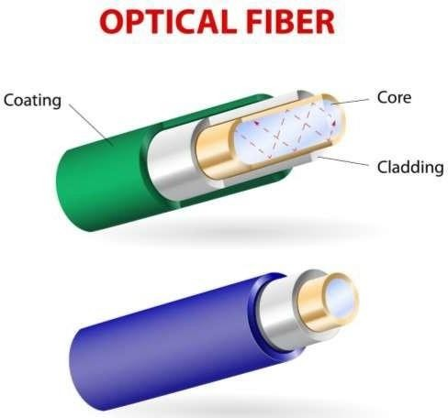

Optical fibre is rapidly replacing copper wires in telephone lines, internet communication and even cable TV connections because transmitted data can travel very long distances without weakening. **Single node** fibre optic cable can have maximum segment length of 2 kms and bandwidth of up to 100 Mbps. **Multi-node** fibre optic cable can have maximum segment length of 100 kms and bandwidth up to 2 Gbps.

## Advantages of Optical Fibre

Optical fibre is fast replacing copper wires because of these advantages that it offers −

* High bandwidth
* Immune to electromagnetic interference
* Suitable for industrial and noisy areas
* Signals carrying data can travel long distances without weakening

## Disadvantages of Optical Fibre

Despite long segment lengths and high bandwidth, using optical fibre may not be a viable option for every one due to these disadvantages −

* Optical fibre cables are expensive
* Sophisticated technology required for manufacturing, installing and maintaining optical fibre cables
* Light waves are unidirectional, so two frequencies are required for full duplex transmission

## Infrared

Low frequency infrared waves are used for very short distance communication like TV remote, wireless speakers, automatic doors, hand held devices etc. Infrared signals can propagate within a room but cannot penetrate walls. However, due to such short range, it is considered to be one of the most secure transmission modes.

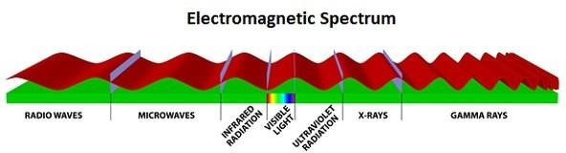

## Radio Wave

Transmission of data using radio frequencies is called **radio-wave transmission**. We all are familiar with radio channels that broadcast entertainment programs. Radio stations transmit radio waves using **transmitters**, which are received by the receiver installed in our devices.

Both transmitters and receivers use antennas to radiate or capture radio signals. These radio frequencies can also be used for **direct voice communication** within the **allocated range**. This range is usually 10 miles.

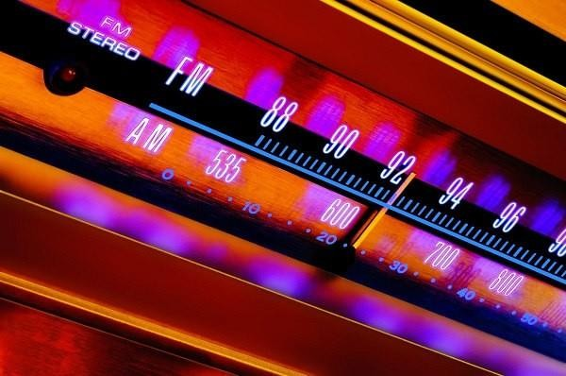

## Advantages of Radio Wave

These are some of the advantages of radio wave transmissions −

* Inexpensive mode of information exchange
* No land needs to be acquired for laying cables
* Installation and maintenance of devices is cheap

## Disadvantages of Radio Wave

These are some of the disadvantages of radio wave transmissions −

* Insecure communication medium
* Prone to weather changes like rain, thunderstorms, etc

# Switching in Computer Networks

Switching is process to forward packets coming in from one port to a port leading towards the destination. When data comes on a port it is called ingress, and when data leaves a port or goes out it is called egress. A communication system may include number of switches and nodes. At broad level, switching can be divided into two major categories:

* **Connectionless:** The data is forwarded on behalf of forwarding tables. No previous handshaking is required and acknowledgements are optional.
* **Connection Oriented:** Before switching data to be forwarded to destination, there is a need to pre- establish circuit along the path between both endpoints. Data is then forwarded on that circuit. After the transfer is completed, circuits can be kept for future use or can be turned down immediately.

## Circuit Switching

When two nodes communicate with each other over a dedicated communication path, it is called circuit switching.There 'is a need of pre-specified route from which data will travels and no other data is permitted.In circuit switching, to transfer the data, circuit must be established so that the data transfer can take place.

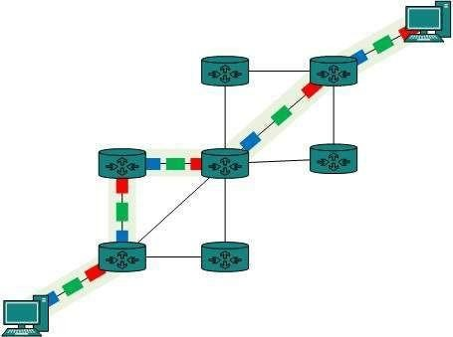

Circuits can be permanent or temporary. Applications which use circuit switching may have to go through three phases:

* Establish a circuit
* Transfer the data
* Disconnect the circuit

Circuit switching was designed for voice applications. Telephone is the best suitable example of circuit switching. Before a user can make a call, a virtual path between caller and callee is established over the network

## Message Switching

This technique was somewhere in middle of circuit switching and packet switching. In message switching, the whole message is treated as a data unit and is switching / transferred in its entirety.

A switch working on message switching, first receives the whole message and buffers it until there are resources available to transfer it to the next hop. If the next hop is not having enough resource to accommodate large size message, the message is stored and switch waits.

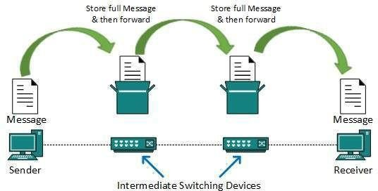

This technique was considered substitute to circuit switching. As in circuit switching the whole path is blocked for two entities only. Message switching is replaced by packet switching. Message switching has the following drawbacks:

* Every switch in transit path needs enough storage to accommodate entire message.
* Because of store-and-forward technique and waits included until resources are available, message switching is very slow.
* Message switching was not a solution for streaming media and real-time applications.

## Packet Switching

Shortcomings of message switching gave birth to an idea of packet switching. The entire message is broken down into smaller chunks called packets. The switching information is added in the header of each packet and transmitted independently.

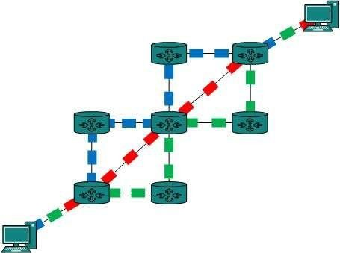It is easier for intermediate networking devices to store small size packets and they do not take much resources either on carrier path or in the internal memory of switches.

Packet switching enhances line efficiency as packets from multiple applications can be multiplexed over the carrier. The internet uses packet switching technique. Packet switching enables the user to differentiate data streams based on priorities. Packets are stored and forwarded according to their priority to provide quality of service.

# Encoding in Computer Networks

**Encoding** is the process of converting the data or a given sequence of characters, symbols, alphabets etc., into a specified format, for the secured transmission of data. **Decoding** is the reverse process of encoding which is to extract the information from the converted format.

## Data Encoding

Encoding is the process of using various patterns of voltage or current levels to represent **1s** and **0s** of the digital signals on the transmission link.

The common types of line encoding are Unipolar, Polar, Bipolar, and Manchester.

## Encoding Techniques

The data encoding technique is divided into the following types, depending upon the type of data conversion.

* + **Analog data to Analog signals** − The modulation techniques such as Amplitude Modulation, Frequency Modulation and Phase Modulation of analog signals, fall under this category.
  + **Analog data to Digital signals** − This process can be termed as digitization, which is done by Pulse

Code Modulation *PCM*. Hence, it is nothing but digital modulation. As we have already discussed, sampling and quantization are the important factors in this. Delta Modulation gives a better output than PCM.

* + **Digital data to Analog signals** − The modulation techniques such as Amplitude Shift Keying *ASK* Frequency Shift Keying *FSK*, Phase Shift Keying *PSK* etc., fall under this category. These will be discussed in subsequent chapters.
  + **Digital data to Digital signals** − These are in this section. There are several ways to map digital data to digital signals. Some of them are −

## Non Return to Zero *NRZ*

NRZ Codes has **1** for High voltage level and **0** for Low voltage level. The main behavior of NRZ codes is that the voltage level remains constant during bit interval. The end or start of a bit will not be indicated and it will maintain the same voltage state, if the value of the previous bit and the value of the present bit are same. The following figure explains the concept of NRZ coding.

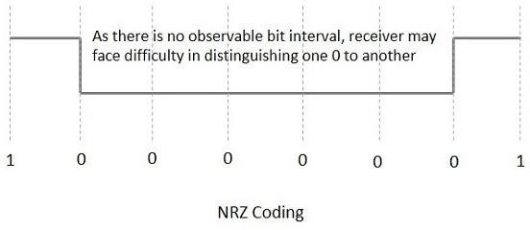

If the above example is considered, as there is a long sequence of constant voltage level and the clock synchronization may be lost due to the absence of bit interval, it becomes difficult for the receiver to differentiate between 0 and 1.

There are two variations in NRZ namely −

**NRZ - L *NRZ*–*LEVEL***

There is a change in the polarity of the signal, only when the incoming signal changes from 1 to 0 or from 0 to 1. It is the same as NRZ, however, the first bit of the input signal should have a change of polarity.

## NRZ - I NRZ–INVERTED

If a **1** occurs at the incoming signal, then there occurs a transition at the beginning of the bit interval. For a **0**

at the incoming signal, there is no transition at the beginning of the bit interval.

NRZ codes has a **disadvantage** that the synchronization of the transmitter clock with the receiver clock gets completely disturbed, when there is a string of **1s** and **0s**. Hence, a separate clock line needs to be provided.

## Bi-phase Encoding

The signal level is checked twice for every bit time, both initially and in the middle. Hence, the clock rate is double the data transfer rate and thus the modulation rate is also doubled. The clock is taken from the signal itself. The bandwidth required for this coding is greater.

There are two types of Bi-phase Encoding.

* + Bi-phase Manchester
  + Differential Manchester

## Bi-phase Manchester

In this type of coding, the transition is done at the middle of the bit-interval. The transition for the resultant

pulse is from High to Low in the middle of the interval, for the input bit 1. While the transition is from Low to High for the input bit **0**.

## Differential Manchester

In this type of coding, there always occurs a transition in the middle of the bit interval. If there occurs a transition at the beginning of the bit interval, then the input bit is **0**. If no transition occurs at the beginning of the bit interval, then the input bit is **1**.

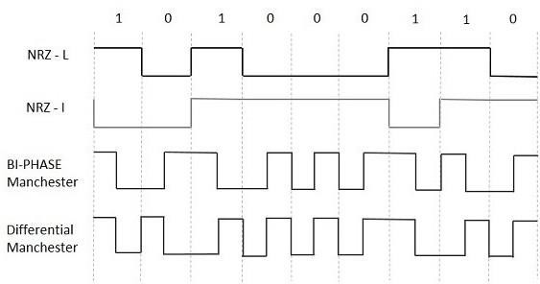The following figure illustrates the waveforms of NRZ-L, NRZ-I, Bi-phase Manchester and Differential Manchester coding for different digital inputs.

## Block Coding

Among the types of block coding, the famous ones are 4B/5B encoding and 8B/6T encoding. The number of bits are processed in different manners, in both of these processes.

## 4B/5B Encoding

In Manchester encoding, to send the data, the clocks with double speed is required rather than NRZ coding. Here, as the name implies, 4 bits of code is mapped with 5 bits, with a minimum number of **1** bits in the group.

The clock synchronization problem in NRZ-I encoding is avoided by assigning an equivalent word of 5 bits in the place of each block of 4 consecutive bits. These 5-bit words are predetermined in a dictionary.

The basic idea of selecting a 5-bit code is that, it should have **one leading 0** and it should have **no more than two trailing 0s**. Hence, these words are chosen such that two transactions take place per block of bits. **8B/6T Encoding**

We have used two voltage levels to send a single bit over a single signal. But if we use more than 3 voltage levels, we can send more bits per signal.

For example, if 6 voltage levels are used to represent 8 bits on a single signal, then such encoding is termed as 8B/6T encoding. Hence in this method, we have as many as

729 (36) combinations for signal and 256 (28) combinations for bits.

These are the techniques mostly used for converting digital data into digital signals by compressing or coding them for reliable transmission of data.